**Objective of the Lab/Program**

The program will first print an unsorted array, then arrange them in descending order and finally print the assorted array

**Assembly Source Codes**

.data

array: .word 10, 22, 45, 80, 60, 82, 77, 63, 25, 93

arraysort: .word

size: .word 10

unsort: .asciiz "Unsorted array: "

sort: .asciiz "\nSorted array: "

space: .asciiz " "

.text

#defining variables

move $t4, $0 #printing counter

la $t0, array #Contains the array

lw $t1, 0($t0) #temp 1

lw $t2, 4($t0) #temp2

li $t3, 0 #inside counter

li $t5, 0 #outside counter

#printing the unsorted array

la $a0, unsort

li $v0, 4

syscall

fake_print:

beq $t4, 10, start #check if all numbers in the array are printed

lw $a0, ($t0) #pointer pointing to a specific index of an array

li $v0, 1

syscall

la $a0, space

li $v0, 4

syscall

addi $t4, $t4, 1

addi $t0, $t0, 4

j fake_print

start:

subi $t0, $t0, 40

move $t4, $0

loop:

beq $t3, 10, iterdone

blt $t1, $t2, swap

addi $t0 ,$t0, 4

lw $t1,0($t0)

lw $t2,4($t0)

addi $t3, $t3, 1

j loop

swap:

sw $t1, 4($t0) #array[x+1] = $t1

sw $t2, 0($t0) #array[x] = $t2

addi $t0, $t0, 4 #increase index of array by 1

lw $t1, 0($t0) #$t1= array[counter]

lw $t2, 4($t0) #$t1=array[counternum+1]

addi $t3, $t3, 1 #add 1 to the counter.

j loop

#Excute after an entire 10 loops occur

iterdone:

subi $t0, $t0, 40 #Reset array to index 0

lw $t1, 0($t0) #set $t1 back to array[1]

lw $t2, 4($t0) #set $t2 back to array[2]

move $t3, $0 #set inner counter to 0

beq $t5, 10, printing_loop #stops looping and prints array if it had looped 10 times

addi $t5, $t5 ,1 #add 1 to outer coutner

j loop

#print string

printing_loop:

la $a0, sort

li $v0, 4

syscall

real_print:

beq $t4, 10, exit #check if all numbers in the array are printed

lw $a0, ($t0) #pointer pointing to a specific index of an array

li $v0, 1

syscall

la $a0, space

li $v0, 4

syscall

addi $t4, $t4, 1

addi $t0, $t0, 4

j real_print

exit:

li $v0, 10 #terminate program

syscall

**Screen shot of the results**

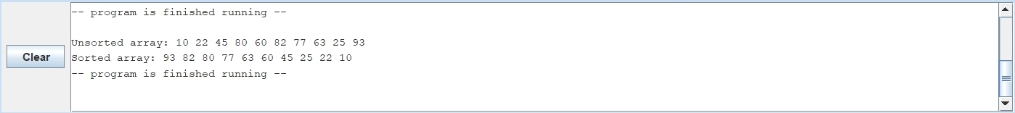

**Conclusion and References**

The program uses the code created from lab 4 to print the array and then utilizes bubble sorting to sort the array.